NAME: OMOBOLA OLAJIDE

[omobola.olajide@Womentechsters.org](mailto:omobola.olajide@Womentechsters.org)

**PRACTICAL ACTIVITY 4**

This week’s Practical Activity will be based on Bash script Programming. As a system Administrator in the near future, you will be expected to understand the structure of Bash Scripts and also you might encounter this type of questions in an interview scenario.

**Question**

Write a shell script to validate password strength when a user enters. Here are a few assumptions for the password string.

Length – minimum of 8 characters.

Contain both alphabet and number.

Include both the small and capital case letters.

If the password doesn’t comply with any of the above conditions, then the script should report it as a <Weak Password> if the password complies with the conditions, it should echo <Strong Password Secure User>

**Instructions**

**Part 1**

Write the code in a file created in your home directory and call it auntentic.sh

Just the same way we have created scripts execute it and use nano editor to add your code.

**My report**

* As shown in the screenshot below, I first tried to check my directory with the ‘pwd’ command and it shows that i’m already working from my home directory so no need to change it.
* Then I created my auntentich.sh file using the ‘touch’ command.
* Afterwards I listed with “ls” to be sure the file has been created.
* Then i entered into my nano editor with nano auntentetic.sh .

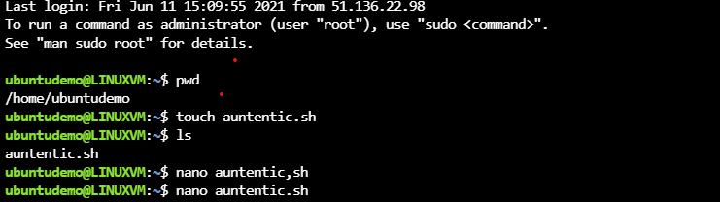

After words Screenshot, your Code Paste it in a word Document as part one of your Report.

* Here is a screenshot of the code I wrote

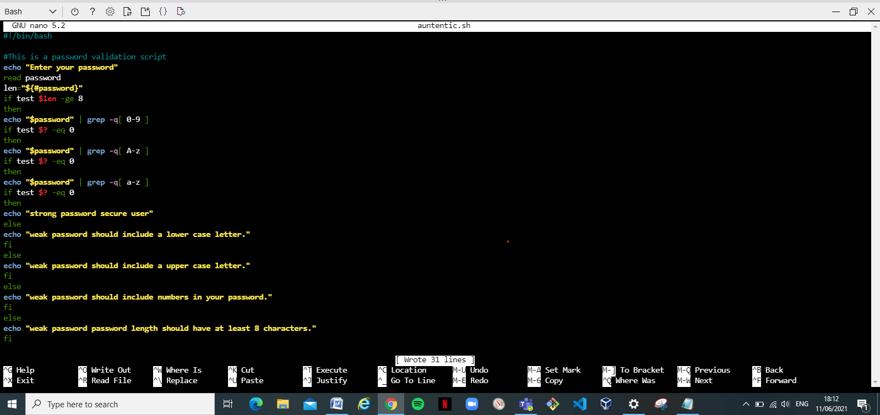

**Part 2**

Also test your script by typing different passwords and screenshot the output from your terminal and add to your report document.

* In the screenshot below, I tested my password with 15 and it echos “weak password length should have at least 8 characters “ as programmed.

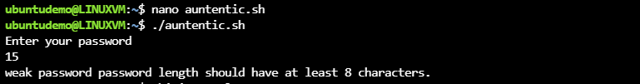

In the screenshot below, I tested my password with “thisissocool” and it echos “weak password length should include numbers in your password “as programmed

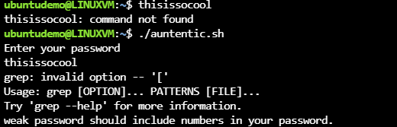

In the screenshot below, I tested my password with THIISSOCOOL“”and it echos “weak password length should include numbers in your password “as programmed.

